# Dobbs Elementary School

**Date: September 9, 2021 Time: 4:00 p.m. – 6:00 p.m.**

**Location: ZOOM**

1. **Call to order:** 4:05 p.m.

## Roll Call

|  |  |  |
| --- | --- | --- |
| **Role** | **Name** *(or Vacant)* | **Present or**  **Absent** |
| **Principal** | Tiffany Ragin | Present |
| **Parent/Guardian** | Symba Lawal | Present |
| **Parent/Guardian** | Kimberly Whitt | Absent |
| **Parent/Guardian** | Maricela Lucas | Absent |
| **Instructional Staff** | Elizabeth Gordon | Present |
| **Instructional Staff** | Ladonna Smith | Present |
| **Instructional Staff** | Lashun Thompson-McGee | Present |
| **Community Member** | Jeremy Crane | Present |
| **Community Member** | Vacant |  |
| **Swing Seat** | Vacant |  |
| **Student** *(High Schools)* |  |  |

**Quorum Established:** Yes

1. **Action Items** 
   1. **Approval of Agenda:** Motion made by: Bailey Dawson; Seconded by: Jeremy Crane

Members Approving: **All**

Members Opposing: **None**

Members Abstaining: **None**

**Motion (Passes)**

* 1. **Fill Vacant Positions**

|  |  |
| --- | --- |
| **Vacant Position:** | **Chair** |
| **Nominee’s Name:** | Kristall Manns-Durden |
| GO Team Members  **In favor** | All |
| GO Team Members  **Opposed** | None |
| GO Team Members  **Abstaining** | None |

|  |  |
| --- | --- |
| **Vacant Position:** | **Co-Chair** |
| **Nominee’s Name:** | Bailey Dawson |
| GO Team Members  **In favor** | All |
| GO Team Members  **Opposed** | None |
| GO Team Members  **Abstaining** | None |

## Fill Open Community Member Seat:

|  |  |
| --- | --- |
| **Open Position:** | **Community Member** |
| **Nominee’s Name:** | Bailey Dawson |
| GO Team Members  **In favor** | All |
| GO Team Members  **Opposed** | None |
| GO Team Members  **Abstaining** | None |

* 1. **Fill Open Swing Seat**

|  |  |
| --- | --- |
| **Open Position:** | **Swing Seat** |
| **Nominee’s Name:** | Kristall Manns-Durden |
| **Nominated by** |  |
| GO Team Members  **In favor** | All |
| GO Team Members  **Opposed** | None |
| GO Team Members  **Abstaining** | None |

|  |  |
| --- | --- |
| **Vacant Position:** | **Secretary** |
| **Nominee’s Name:** | Elizabeth Gordon |
| GO Team Members  **In favor** | All |
| GO Team Members  **Opposed** | None |
| GO Team Members  **Abstaining** | None |

|  |  |
| --- | --- |
| **Vacant Position:** | **Cluster Representative** |
| **Nominee’s Name:** | Ladonna Smith |
| GO Team Members  **In favor** | All |
| GO Team Members  **Opposed** | None |
| GO Team Members  **Abstaining** | None |

* 1. **Approval of Previous Minutes: 05/13/2021**
  2. Motion made by: Jeremy Crane; Seconded by: Bailey Dawson
  3. Members Approving: All

Members Opposing: None

Members Abstaining: None

**Motion: Passes**

* 1. **Review and Approve Public Comment Format** 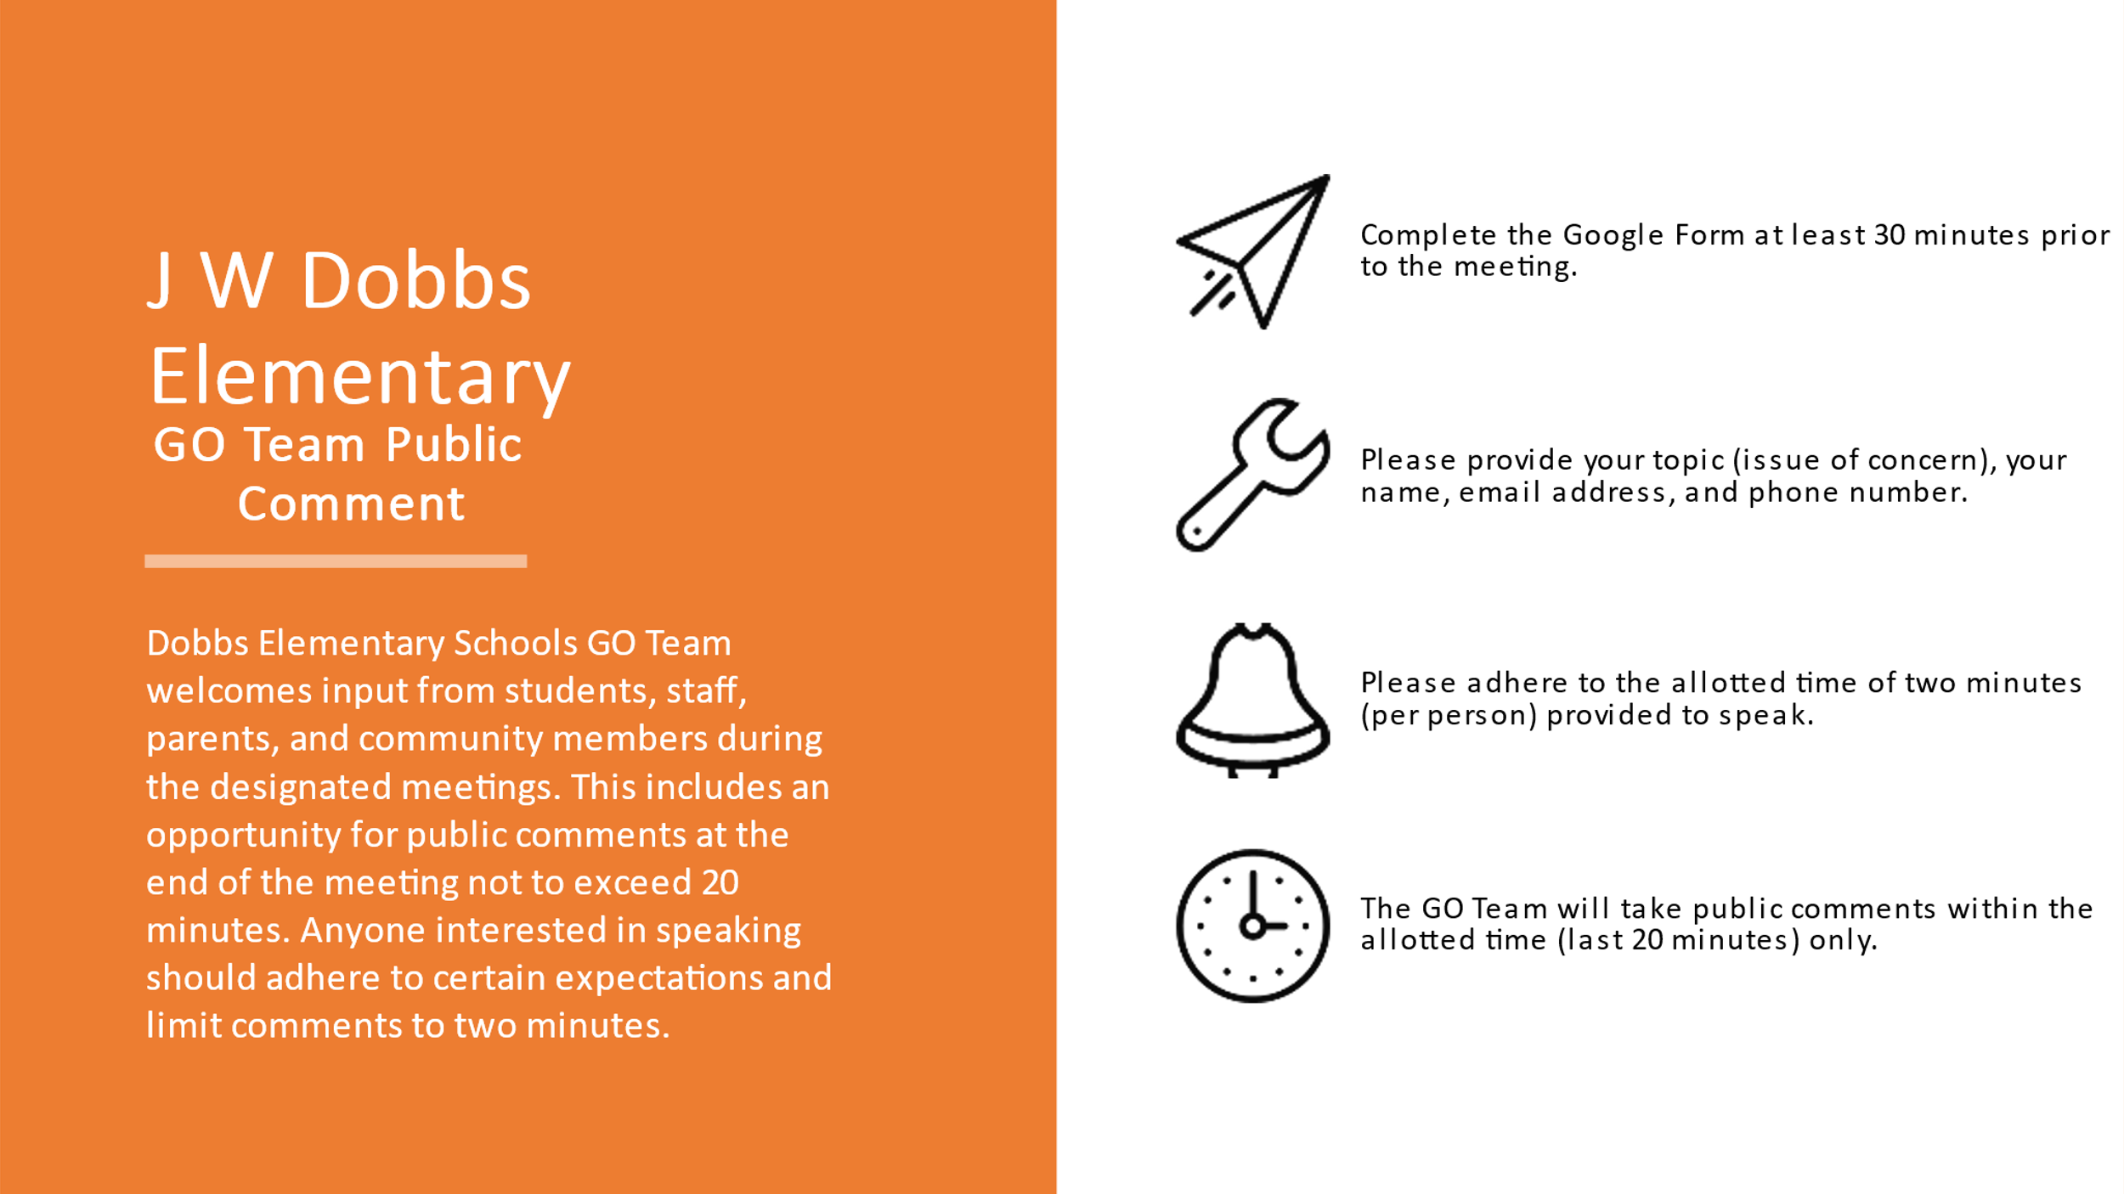
  2. Motion to adopt made by: Bailey Dawson; Seconded by: Lashaun Thompson-McGee

Members Approving: All

Members Opposing: None

Members Abstaining: None

**Motion** Passes

* 1. **Set GO Team Meeting Calendar**

|  |  |  |  |  |
| --- | --- | --- | --- | --- |
|  | **Date** | **Time** | **Location** | **Public Comment Permitted?**  **(Yes/No)** |
| **1** | 9/9/2021 | 4-6:00 p.m. | ZOOM | YES |
| **2** | 10/14/2021 | 4-6:00 p.m. | ZOOM | YES |
| **3** | 11/18/2021 | 4-6:00 p.m. | ZOOM | YES |
| **4** | 1/20/2022 | 4-6:00 p.m. | ZOOM | YES |
| **5** | 2/24/2022 | 4-6:00 p.m. | ZOOM | YES |
| **6** | 4/24/2022 | 4-6:00 p.m. | ZOOM | YES |
| **7** |  |  |  |  |
| **8** |  |  |  |  |

## Review, Confirm/Update, and Adopt GO Team Meeting Norms

Members Approving: All

Members Approving: None

Members Approving: None

**Motion (Passes)**

1. **Discussion Items** 
   1. **Discussion Item 1**: Improvement Plan for 2021-2022 School Year: **Principal Ragin informed the team that the plan was in progress. She informed the team that the leadership team is analyzing the data from the 2019 GMAS. The results of that analysis will determine how Dobbs will move forward with the improvement plan. It will be discussed next meeting.**
   2. **Discussion Item 2**: **GMAS Assessment Results and Leveling: The GMAS results from 2019 was viewed. Principal Ragin informed the team about intervention programs that has been put into place to help grow the students of Dobbs Elementary.**
2. **Information Items**

**The team was informed about the mandatory surveillance testing for Covid-19.**

**ADJOURNED AT 4:52 p.m**.

**Minutes Taken By: Elizabeth Gordon**

**Position: Secretary**

**Date Approved:**